1. Open your CS:Source local installation directory by going to game properties in Steam, then local files, then clicking on the “view installation directory”.
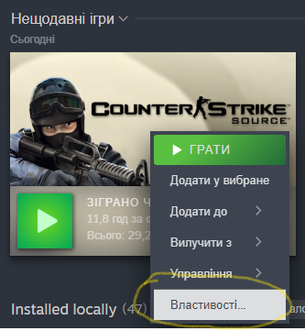
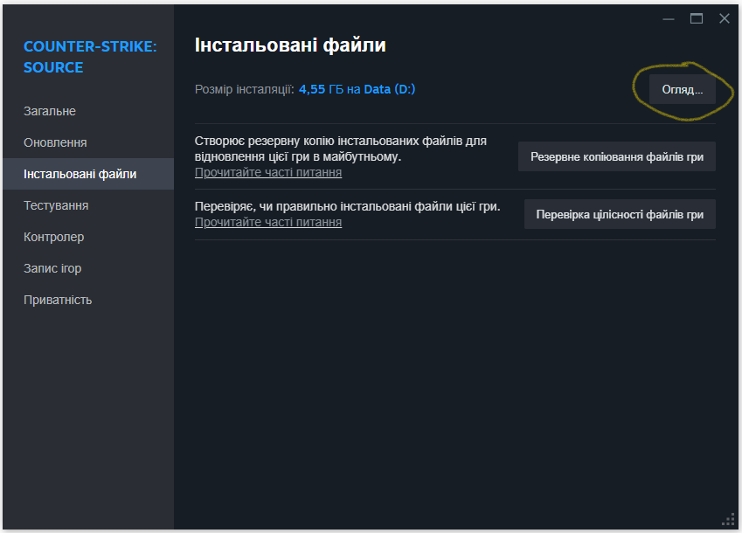
2. Copy the contents of this archive into the root folder.
3. ...
4. Profit!

